1: Create user with name Techie and provide sudo access to user.
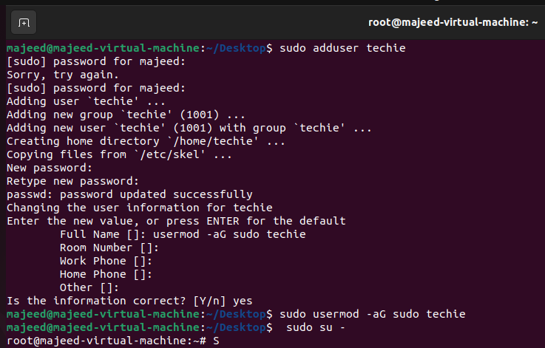
2: Navigate to the home directory.
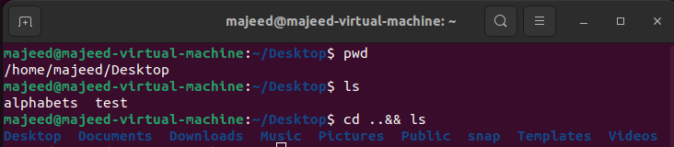
3: Create a new directory.
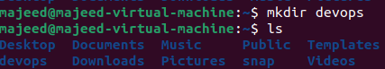
4: List the contents of a directory.
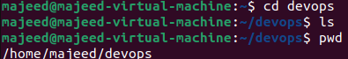
5: Change the current directory.
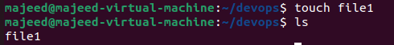
6: Create a new empty file
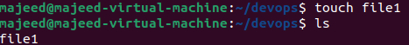
7: View the contents of a file.
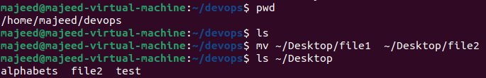

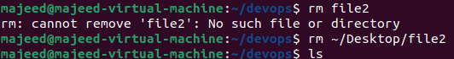
12 :Grant or revoke permissions on a file or directory.
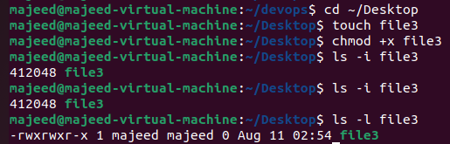
13: View the current date and time.
14: Check the system uptime.
15: View the running processes.
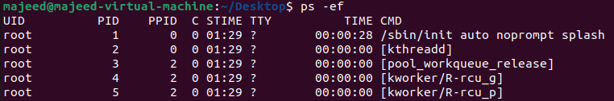
16: Kill a running process.
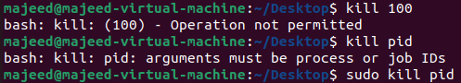
17: Install a package using the package manager (e.g., apt or yum).
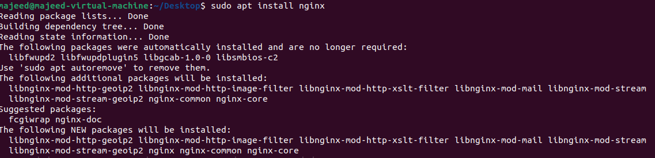
18: Update the system packages.
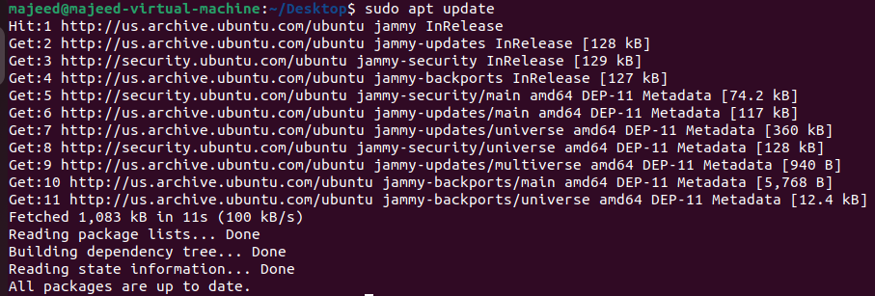
19: Create a symbolic link.
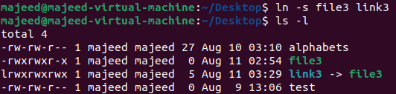
20: Search for files using the find command.
21: Compress and decompress files using tar.
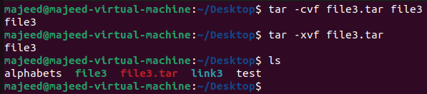
22: Monitor system resources with top or htop
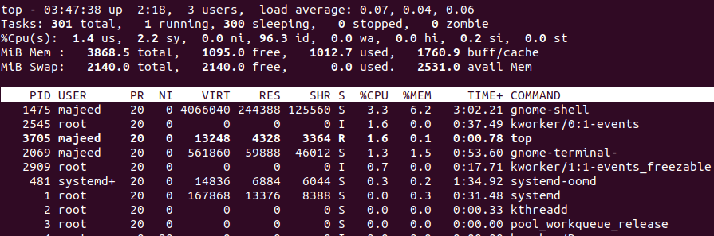
23: Create and manage user groups.
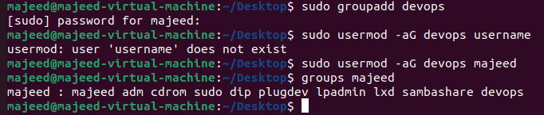
24: Set up SSH password less authentication.
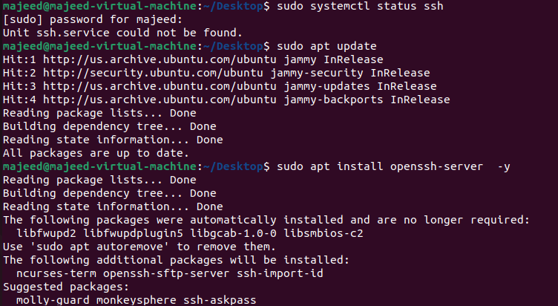
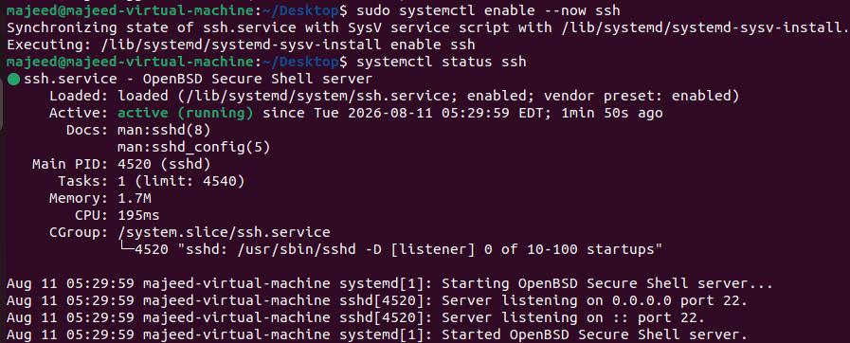
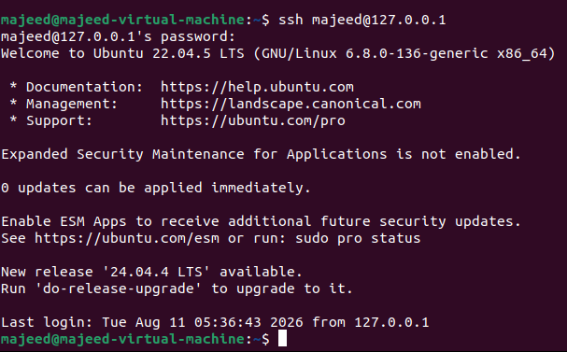
25: Monitor log files using tail or grep.
*tail → Shows the latest lines of a log file, and can continuously display new log entries.
* grep → Searches a log file for specific words, such as error, failed, or warning.
*tail -f /var/log/syslog
* grep "error" /var/log/syslog
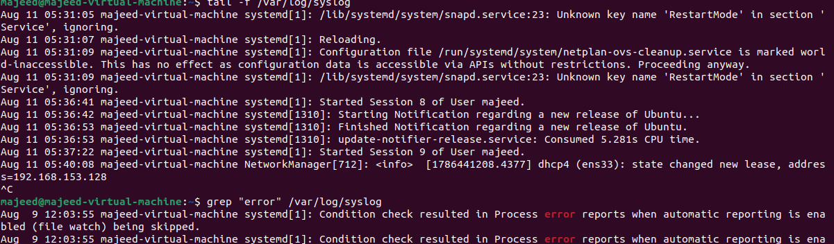
26: Set up a web server (e.g., Apache or Nginx).
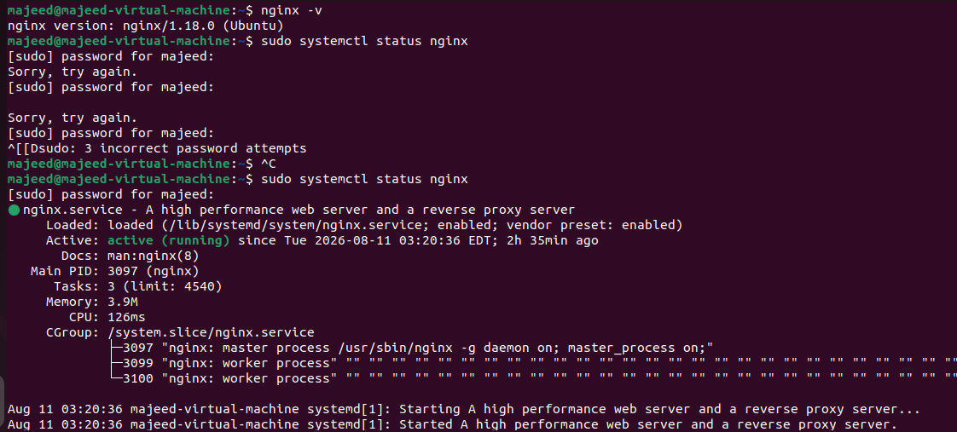
27: Configure and secure a MySQL Database.
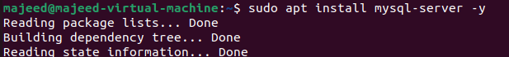
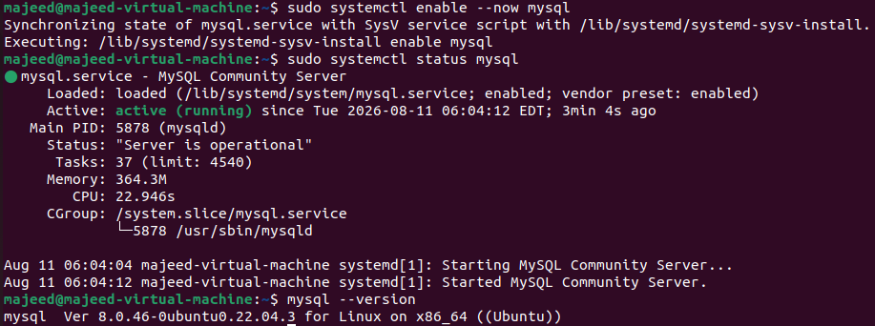28: Set up a Application Server (e.g.,Apache Tomcat)
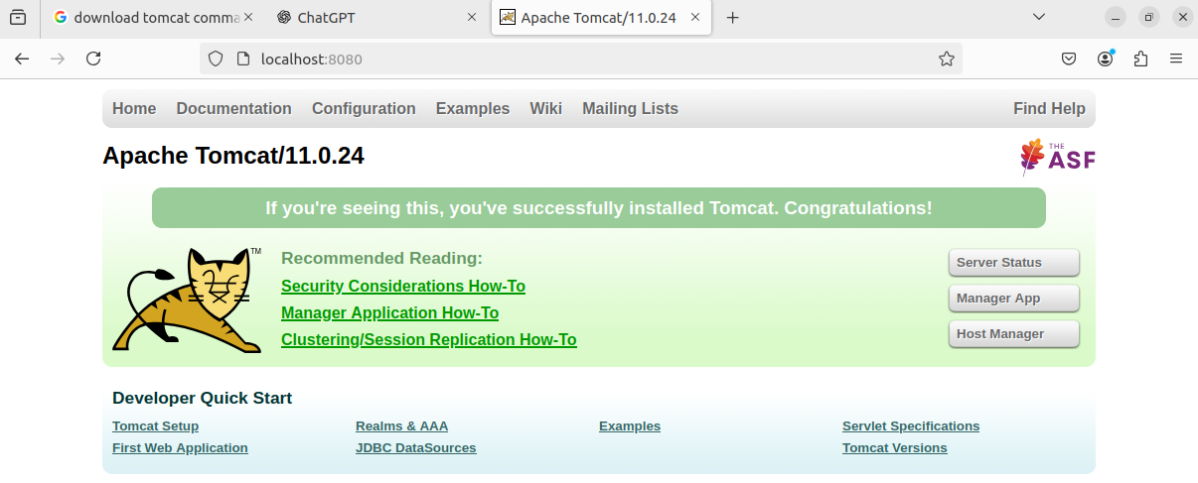
30: Print specific columns from a delimited file.
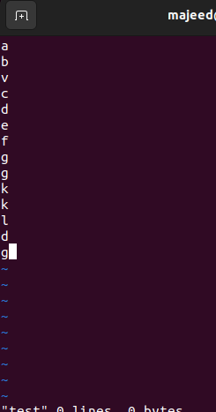
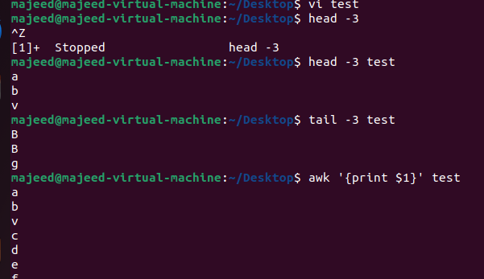
31: Filter and print lines based on a specific pattern or condition.
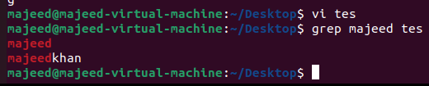
32: Calculate and print the average, sum, or other statistics of a column.
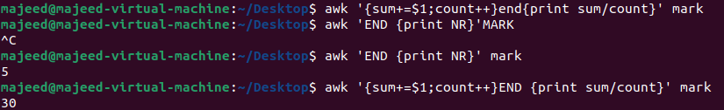
33: Perform string manipulation, such as extracting substrings or changing case.
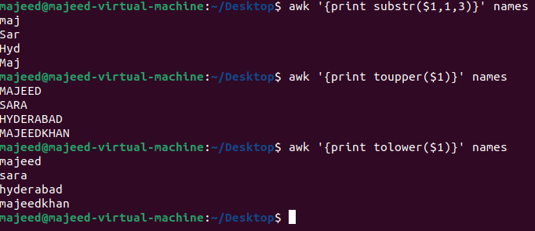
34: Count the occurrences of a specific pattern in a file.
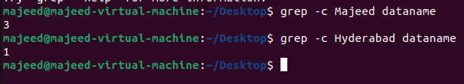
35: Sort lines based on a specific field or column.
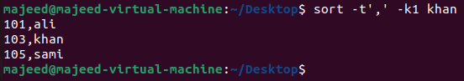
36: Merge multiple files based on a common field or column.
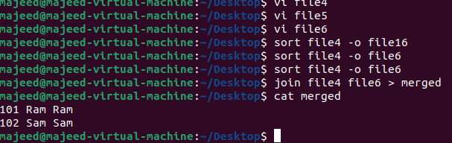
37: Substitute text in a file using search and replace.
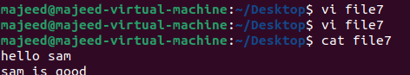
38: Delete specific lines based on a pattern or line number.
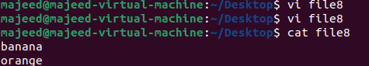
39: Append or insert text before or after a specific pattern or line
ext was inserted after a matching pattern using:
sed -i '/Linux/a This is a new line' file.txt
Text was inserted before a matching pattern using:
sed -i '/Linux/i This line comes before' file.txt
40: Print only specific lines from a file.
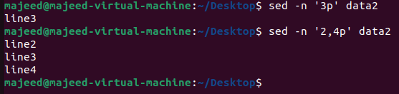
41: Copy file from linux to windows machine
Connect to the AWS EC2 Linux instance
➔ Create a test file (test.txt)
➔ Open Git Bash on Windows – cd ~/Downloads
➔ Copy the file using SCP
➔ $scp -i "mytest_key.pem" ec2-user@54.173.8.41:/home/ec2-user/test.txt ~/Downloads/
➔ Verify the file transfer (test.txt 100% 42 0.1KB/s 00:00)
➔ Verify the file on Windows – (ls -l | grep test.txt)
42: 42. 5 use cases for AWK and 5 use cases for sed
Use case Purpose Command
Print specific columns Extract required fields from a file awk '{print $1, $3}' file.txt
Filter rows based on
condition
Print only matching
records
awk '$3 > 100 {print $1, $3}'
file.txt
Calculate
sum/average
Perform calculations on
columns
awk '{sum += $3} END {print sum}'
file.txt
Count
occurrences
Count lines/records matching a
pattern
awk '/ERROR/ {count++} END {print
count}' app.log
Process delimited
files
Work with CSV/colon-separated
files
awk -F',' '{print $1, $3}'
users.csv

